TESTIMONY NIGHT AT CELEBRATE RECOVERY – STARKE
CALVARY BAPTIST CHURCH
1515 E STATE ROAD 10, KNOX, IN 46534
TUESDAY, AUGUST 13, 2024
Fellowship Meal – 5 PM CST
Large Group Meeting – 6 PM CST

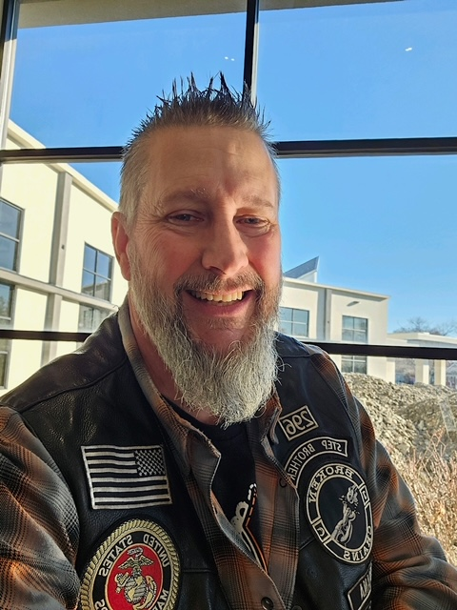
MICKEY CHAKOS
LIVING STONES CHURCH - CROWN POINT, IN
MINISTRIES HE IS INVOLVED IN:
CELEBRATE RECOVERY
BROKEN CHAINS – JESUS CHRIST
WELCOME HOME

We invite you to join us to hear
Mickey’s powerful testimony!!!

